
BONUS TOOL
Town Meeting Agendas
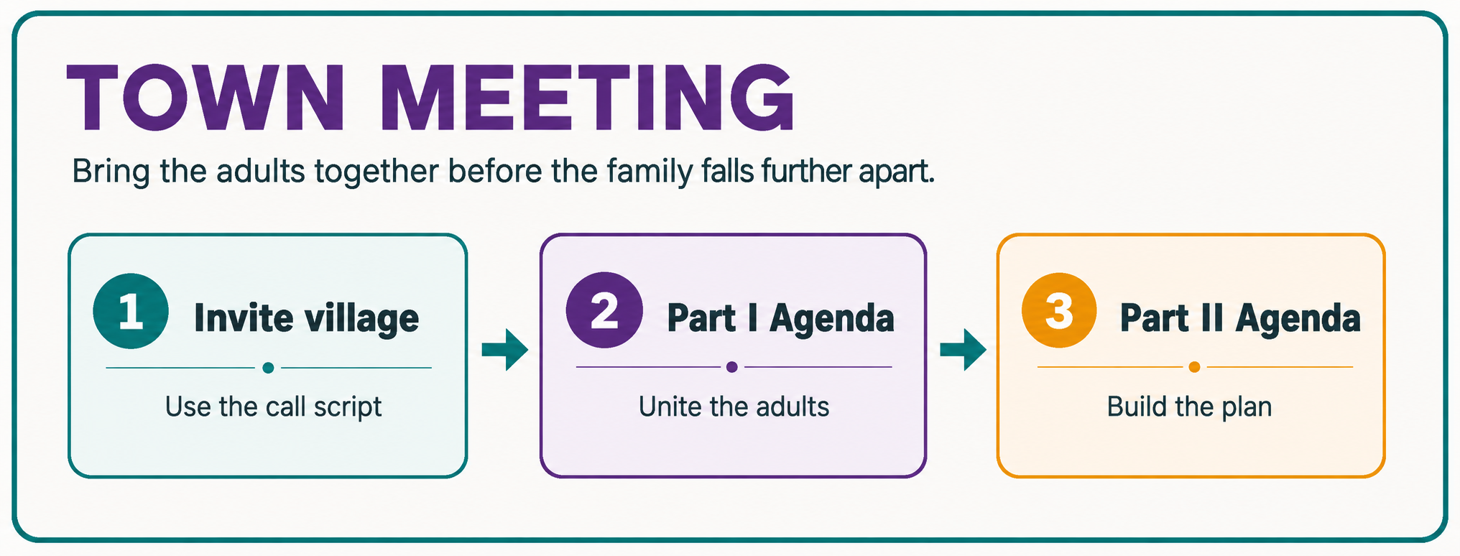
A simple adult-only planning guide for bringing your village together

Use this bonus tool when...
Your teen is struggling and the adults around them are divided, distant, blaming each other, or unsure what to do next. The goal is not to hold therapy. The goal is to bring the adults together, lower the chaos, and create a united plan.

Quick Start: The Three-Part Process
1. Invite your village  Use the short call script to invite key adults. Keep the focus on helping your teen, not rehashing old conflict. | 2. First Town Meeting  Adults meet first. Review ground rules, name the main problems, list what has and has not worked, and pick priorities. | 3. Second Town Meeting  Review a draft plan or contract, clarify each person’s role, and decide when and how to present it to your teen.

Book connection
This manual is designed as a companion to Strategy 3 in Parenting Your Out-of-Control Teenager. The book gives the full teaching; this Word Document gives you blank agendas and a simple structure you can use right away. Watch the Bonus Village Video to See a Sample Village Meeting in Action as a visual illustration

Step 1: Map Your Village
A village is any person or institution outside your immediate family that could help you support your teen. This may include extended family, friends, neighbors, school staff, counselors, probation, child welfare, houses of worship, mentors, or coaches.
Why this matters
Isolation fuels out-of-control behavior. A written map helps you see who is already helping, who might help if asked, and who may be weakening your authority or dividing the adults.

My Village Map
Presently supportive  Who already helps? | Potentially supportive  Who might help if asked? | Not supportive / undermining  Who weakens the plan?
• ___________________________ | • ___________________________ | • ___________________________
• ___________________________ | • ___________________________ | • ___________________________
• ___________________________ | • ___________________________ | • ___________________________
• ___________________________ | • ___________________________ | • ___________________________
• ___________________________ | • ___________________________ | • ___________________________
Possible Villagers to Consider
□ Spouse, co-parent, ex-spouse, step-parent, or significant other
□ Grandparents, aunts, uncles, cousins, adult siblings, or family friends
□ Neighbors, mentors, coaches, pastors, youth leaders, or trusted adults
□ School counselor, teacher, principal, IEP team, or attendance staff
□ Therapist, parent coach, residential program, probation officer, CPS worker, or police liaison

Keep the first ask simple
Do not try to solve the whole problem on the invitation call. Your first goal is only to ask for help and send the agenda ahead of time.

Step 2: Invite Your Village
Start with a calm, focused call or text. Keep it short. The goal is to invite support and send the agenda - not to debate or rehash the past.
Simple Motivational Call Script
Open | Hi [name], this is [your name]. Do you have 10 minutes to talk?
Ask | I could use your help with [teen name].
Name issue | They have been struggling with [anger, depression, aggression, disrespect, school refusal, running away, drugs/alcohol, etc.].
Village frame | I believe it takes a village to help a teen, and you are part of my village.
Focus | I want to call a short, focused Town Meeting with the adults who care about [teen name].
Reassure | This is not therapy and not a blame session. It is a planning meeting.
Send agenda | Can I send you the agenda in advance so you can see the purpose and possible role?
Zoom option | If you are far away, we can include you by Zoom or phone.
Close | Will you come?
If there is old conflict
Acknowledge it briefly and move back to the teen: "I know we have not always agreed. I am not calling to relive that. I am calling because [teen name] needs the adults to work better together now."

Send Before the Meeting
□ Part I agenda
□ Ground rules, if needed
□ Meeting date, time, location, and Zoom link
□ A short note: "Please review this before we meet so we can stay focused."

Why this works
The script keeps the invitation calm, focused on the teenager, and solution-oriented. Calling it a Town Meeting makes it feel practical instead of blaming or therapeutic.

Who Should Be Invited?
□ Parents or co-parents
□ Stepparents or caregivers
□ Grandparents or trusted relatives
□ Mentors, pastors, coaches, or other safe adults
□ A counselor or parent coach, if the situation is high-conflict

Important
The first meeting is usually adults only. Bring your teen in later, after the adults are calmer, more united, and ready to present a plan.

Step 3: First Town Meeting Agenda - Part I
Purpose: Get the adults on the same page before creating a plan for your teen.
Meeting Information
Date / Time | ______________________________
Location or Zoom Link | ______________________________
Meeting Leaders | ______________________________
Adults Attending | ______________________________
Teen attending? | Usually no - adults first
Ground Rules
□ This is not therapy. It is a planning meeting.
□ No rehashing old fights, custody battles, or blame.
□ Focus on what we can do now to help the teen.
□ Stay on the agenda.
□ If things get heated, anyone can call a time-out.
Main Problems to Solve
List the top 1-3 problems. Keep the list focused.
1. ________________________________________________
2. ________________________________________________
3. ________________________________________________
What Has Worked / What Has Not Worked
What has helped? | What has made things worse?
• ____________________________________ | • ____________________________________
• ____________________________________ | • ____________________________________
• ____________________________________ | • ____________________________________
• ____________________________________ | • ____________________________________

First Town Meeting Agenda - Part I Continued
Brainstorm Possible Solutions
1. ________________________________________________
2. ________________________________________________
3. ________________________________________________
4. ________________________________________________
Top Priorities for the Next Meeting
1. ________________________________________________
2. ________________________________________________
3. ________________________________________________
Next Meeting
Date / Time: ___________________________________________
Who will prepare the draft plan or contract? ___________________________
Who will send the agenda? ___________________________________________
Mini Example: Robert’s Family
Robert was struggling after a painful divorce. His mom invited his dad, stepmom, and grandparents to a Town Meeting by Zoom. The adults used ground rules, stayed focused on Robert, and agreed they needed to stop taking sides and work from one plan.

What made the first meeting work?
They sent the agenda ahead of time, kept the meeting adults-only, called time-outs when things got heated, and focused on Robert instead of past adult conflict.

Part I Closing Statement
Close the meeting with something simple:

Suggested wording
Thank you for showing up for [teen name]. We may not agree on everything, but today we took a step toward working together. Before the next meeting, let’s review the possible tools and come ready to build one clear plan.

Step 4: Second Town Meeting Agenda - Part II
Purpose: Review the draft plan, clarify roles, and decide how to put the plan into action.
Meeting Information
Date / Time | ______________________________
Location or Zoom Link | ______________________________
Meeting Leaders | ______________________________
Adults Attending | ______________________________
Teen attending? | □ Yes □ No □ Later in meeting
Draft plan attached? | □ Yes □ No
Agenda Items
1. Review the draft plan | Go line by line. Fix wording that is unclear, too harsh, or too vague.
2. Clarify adult roles | Who will do what? Who will communicate? Who will follow through?
3. Practice the delivery | Adults rehearse how the plan will be presented. Keep it calm and united.
4. Bring in your teen, if ready | Present the plan as a united team. Keep it short. Do not debate.
5. Schedule follow-up | Pick a date to review what worked, what did not, and what needs adjusting.
Role Grid
Person | Role | Next step
________________________ | ________________________ | ________________________
________________________ | ________________________ | ________________________
________________________ | ________________________ | ________________________
________________________ | ________________________ | ________________________

Sample Plan Starter: Connection Outing
Use this starter when the Town Meeting reveals that your teen needs more connection, not just more consequences. Go to Strategies 5 and 6 in your book to choose from a menu of techniques.
Example from Robert’s family
The adults created a camping trip idea with Dad, Stepdad, Grandpa, and Robert. The goal was to help Robert feel less alone and more connected. The details were customized by the family.

Goal | Help [teen name] feel supported, connected, and less alone.
Who is involved | ____________________________________________
What we will do | ____________________________________________
When | ____________________________________________
Where | ____________________________________________
Each adult’s role | ____________________________________________
Teen’s role | ____________________________________________
Follow-up date | ____________________________________________
Before You End Any Town Meeting
□ The next step is clear.
□ Each adult knows their role.
□ The teen is not being blamed for adult division.
□ The plan is written down.
□ A follow-up meeting is scheduled.
□ Everyone knows where to find the agenda and instructions.

Final reminder
A Town Meeting does not have to be perfect to help. It may feel awkward at first. What matters is that the adults stop working separately and start moving in the same direction for the teen.

Step 5: Practice, Launch, and Follow Up
Dress Rehearsal Guide
Plans often fail because families skip practice. Pick the two or three most important scenes and rehearse them before the plan goes live.
□ Choose one likely scene: disrespect, refusal, aggression, school refusal, divide-and-conquer call, or phone conflict.
□ Assign roles: parent, teen, grandparent, counselor, neighbor, or other villager.
□ Practice the scene. Keep it calm, short, and realistic.
□ Say "freeze" and ask: What worked? What needs adjusting?
□ Practice again with the correction.
□ If appropriate, bring your teen in and present the plan as a united team.
Before You End Any Town Meeting
□ The next step is clear.
□ Each adult knows their role.
□ The plan is written down.
□ Loopholes have been checked.
□ Follow-up is scheduled.
□ The teen is not being blamed for adult division.

Final reminder
A Town Meeting does not have to be perfect to help. It may feel awkward. Someone may get emotional. That is normal. What matters is that the adults stop working separately and begin moving in the same direction for the teen.

Want to go deeper?
Read Strategy 3: It Takes a Village in Parenting Your Out-of-Control Teenager.

